Original Store front as designed by the first owner Nancy Maniscalco, Nancy’s wine graphic plate was back lit.

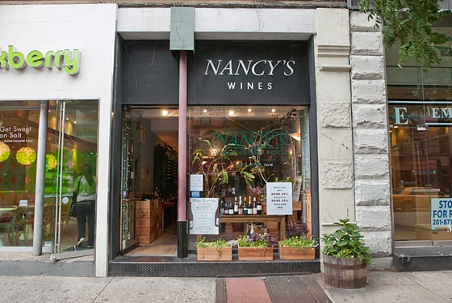

We changed the Nancy’s wines to the present Corks on Columbus signage around Feb 2015.

Building façade prior to Nancy’s wine was started

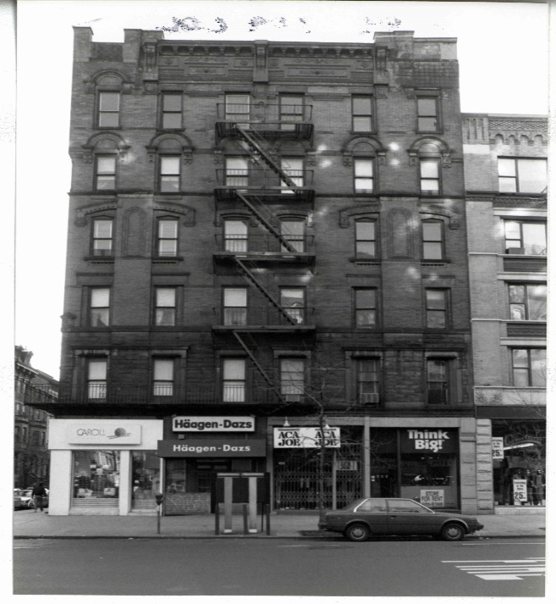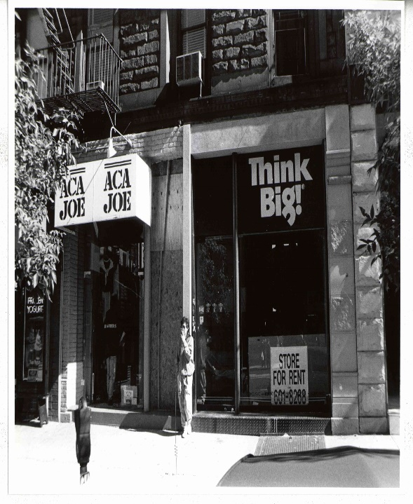
Page1

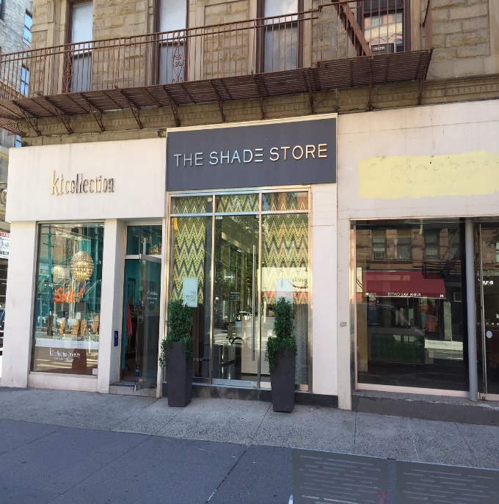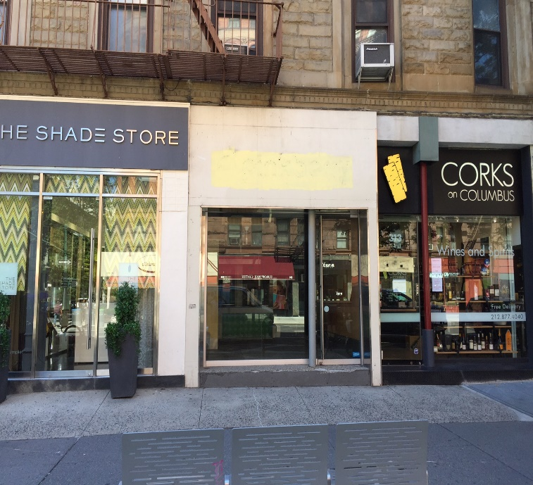
Building façade as of July 26, 2016 left and right sides.

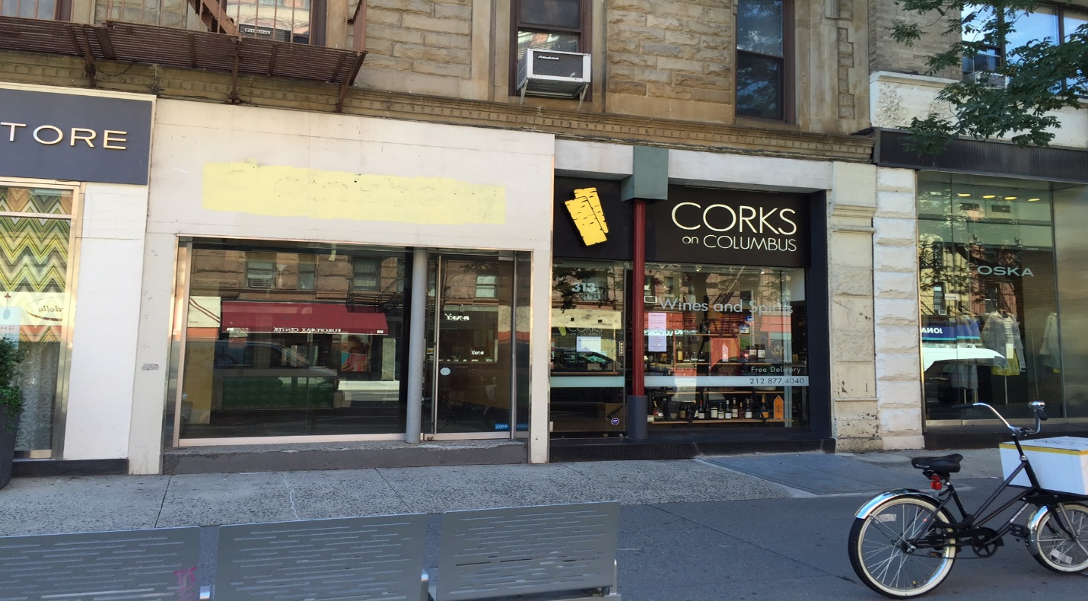

Page 2

LIT SIGNS NEAR FROM CORKS ON COLUMBUS

PATSY’S PIZZERIA 61 W 74 STREET NY, NY 10023 PAPER SOURCE 309 COLUMBUS AVENUE NY, NY 10023

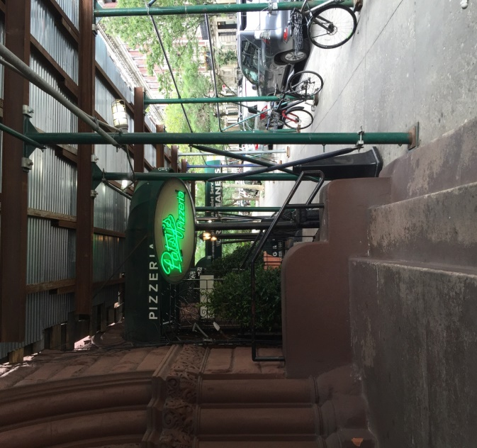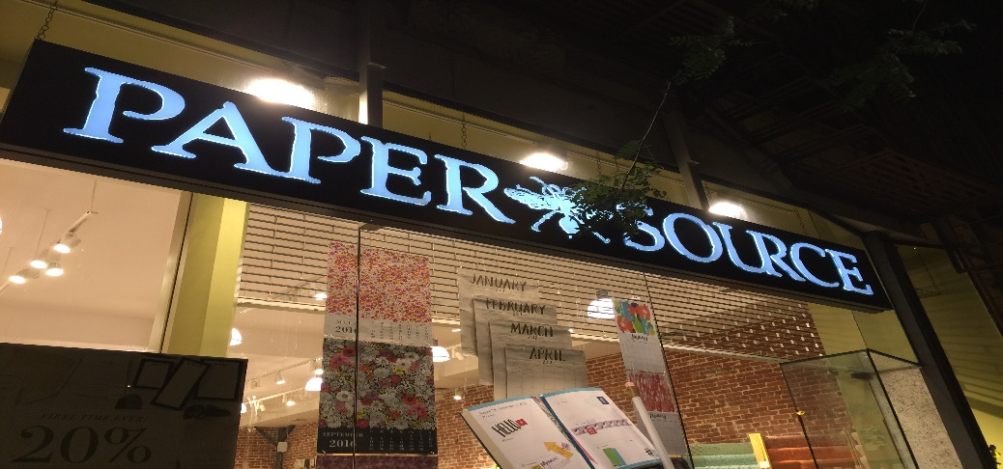

LENWICH AT NIGHT 302 COLUMBUS AVENUE NY, NY 10023
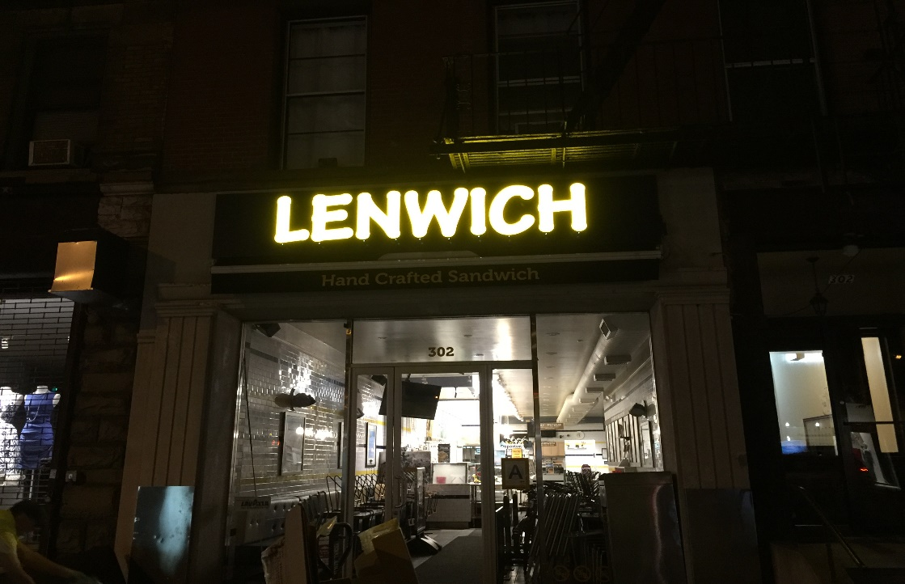
Page 3

RAIN 294 COLUMBUS AVENUE NY, NY 10023

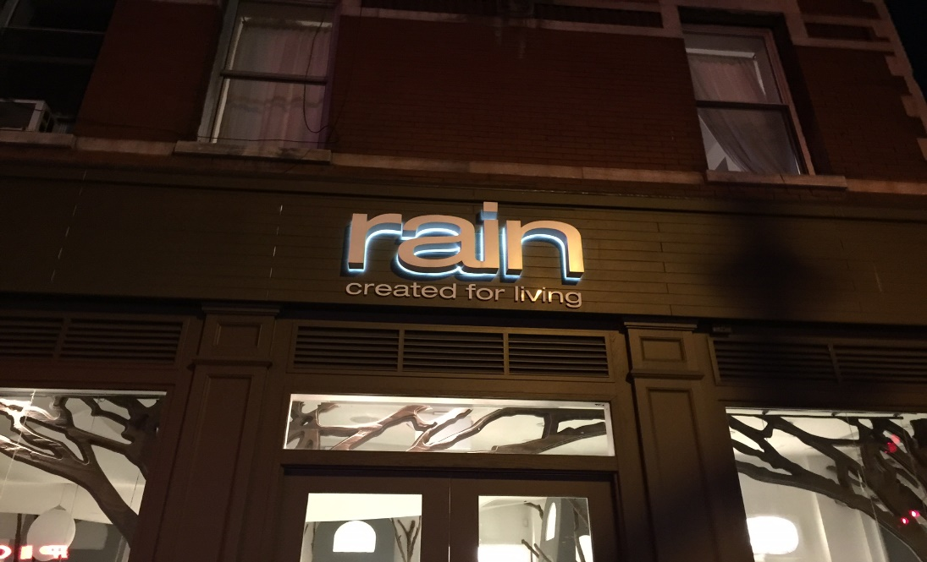

HSBC BANK 301 COLUMBUS AVENUE NY, NY 10023
PICTURES ARE ON 74 STREET
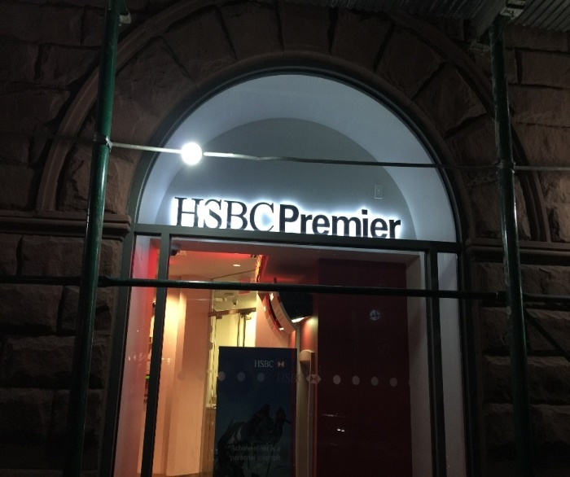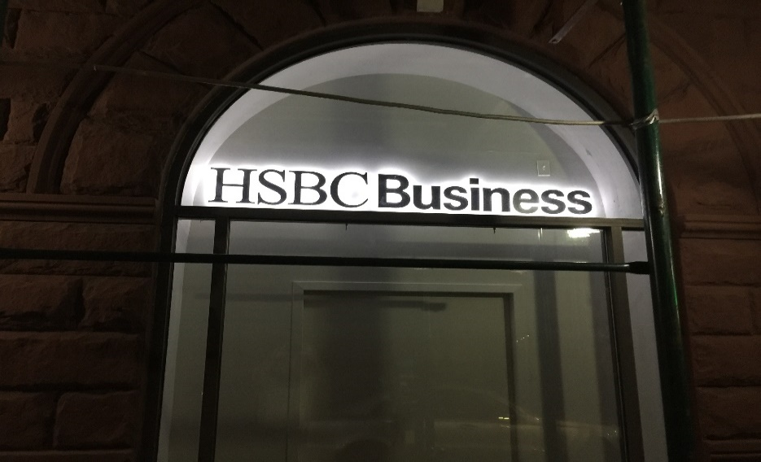

Page 4

PIONEER SUPERMARKET 289 COLUMBUS AVENUE NY, NY 10023
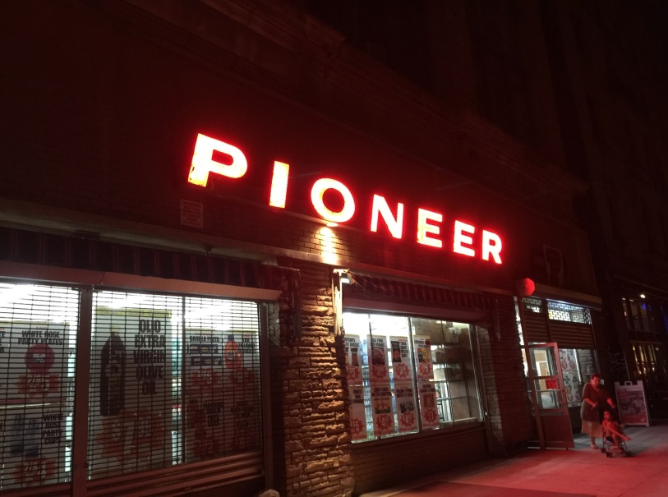

]

PRESENT LOOK OF BUILDING FROM ACROSS THE STREET
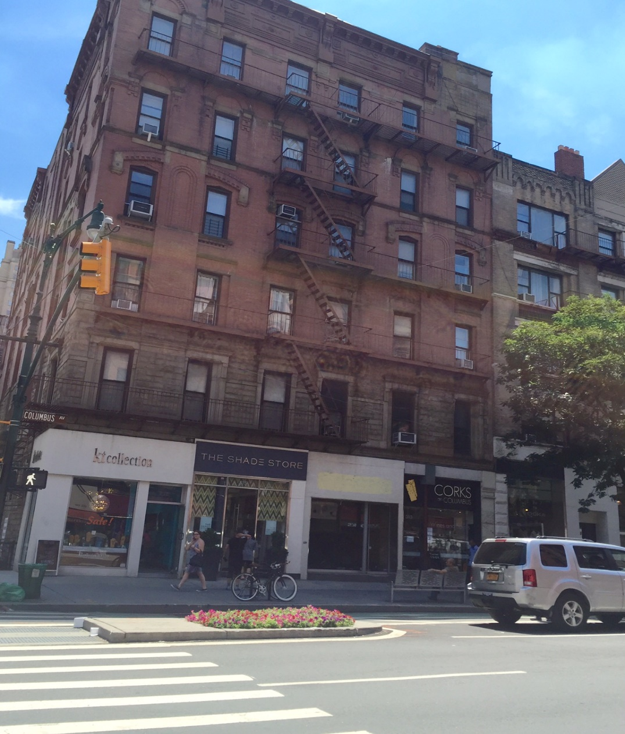
Page 5

PRESENT SIGN OF CORKS ON COLUMBUS LIT AT NIGHT

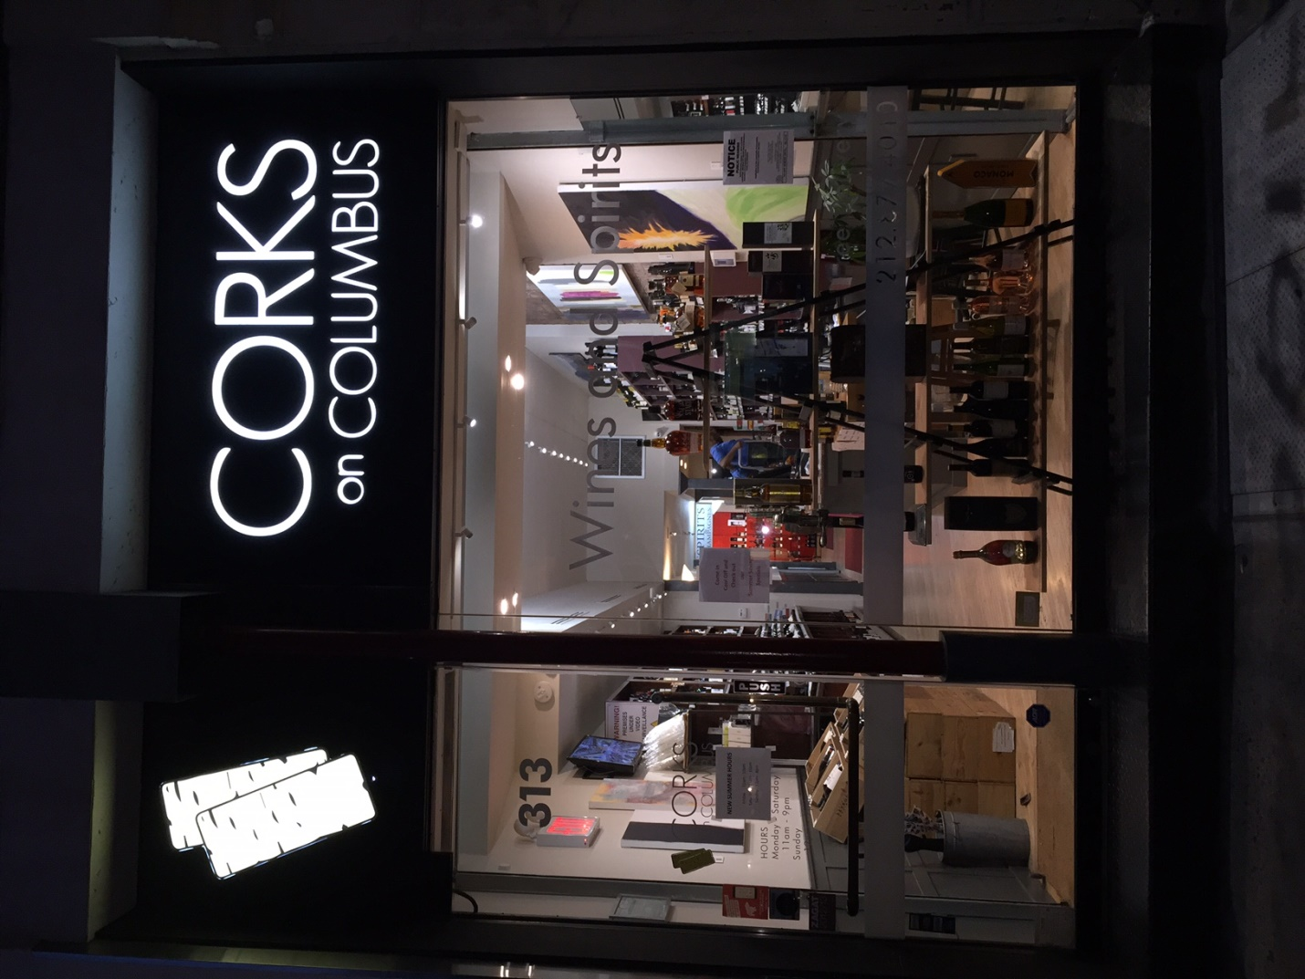

Page 6

